Trip Title
Transport | Road end:
Is authorisation needed to access the road end?*
☐ Yes ☐ No
 | Is there another club trip starting from the same road end? ☐ Yes ☐ No if yes, contact the trip leader to coordinate
Is there more than 2-3h drive?
☐ Yes ☐ No if yes, you’ll need a minimum of 2 drivers
Accommodation
Is booking required? How many hut tickets? Do you need to carry tents?
Max numbers of people
Consider size of the huts and whether you need to share the van
Map | Buy the relevant map or use https://www.topomap.co.nz
Route Description |  |  |  | Estimated distance and/or time*:
Day 1

Day 2

Day 3

Potential hazards*
River crossings vs bridges/no crossings, River travel, Tops travel vs below tree line, Off-track vs on-track travel…
Plan B
Alternative route or shelter. E.g. if a river can’t be crossed
Expected times | Departure time from Wellington station:  Expected time out*:  Raise-alarm time*:  Expected time back in Wellington:

NOTES

*Transport:
- To get the details of another trip leader, email chiefguide@wtmc.org.nz
- To check if you can access the road end:
  - Check the ‘Getting there’ section on the DOC website for that track/hut, or
  - Check the Walking Access Mapping System www.wams.org.nz. If your route crosses private land you need to contact the land owner to obtain permission. DOC usually holds landowner phone numbers.
- More information on transport, including vans, ferries and private transport is available on the website under Trips > For trip leaders > Vans and other transport options.

*Accommodation:
- Check with the Chief Guide if a booking has already been made for your group or if you need to make your own.
- If you are using the club lodge, more info is available here.

*Estimated travel times:
- Use these timings with discretion, considering factors such as experience, group size, weather..
Well-formed tracks 4-6 km/hr
Tramping tracks 2-3 km/hr
Off track, open bush 1-3 km/hr
Off-track, scrub 100-400 m/hr
Off-track, rugged country 6-10 km/day
River travel 1 km/hr
Steep ascent or descent on tracks 300-350 m elevation/hr
- Daylight hours:
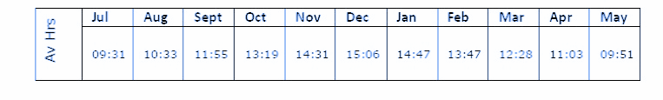
*Potential hazards:
- For information about previous trips to that hut/track, search on the wtmc website for relevant trip reports. This can provide approximate times, track conditions, potential hazards… but also view points, camping spots…
- For up to date information about the track:
  - Call the relevant DOC office and ask about track condition (e.g. possible slips after heavy rain etc)
  - Check if there are any alerts on the DOC website
  - Contact trip leaders who have done this trip or ask the Chief Guide for their details.

*Expected times
- Expected time out: when you expect to be back at the vehicle after your trip and able to text the emergency contact. Consider whether you will have phone reception at the road end, it could take an hour to be able to text the emergency contact.
- Raise-alarm time: If the emergency contact hasn’t heard from you and cannot get hold of you,, they will call 111 to discuss Search and Rescue options.

